NATIOANL CAMP ACHIVERS 2012- 2013
S.No | Name of the Event | Name of the participant | Dates | Place
1. | Pre commission Training Course (PRCN /SD/150) | Lt. B. Saravanakumar | 02 July 2012-29th September 2012 | Officers Training Academy, Nagpur , Maharashtra
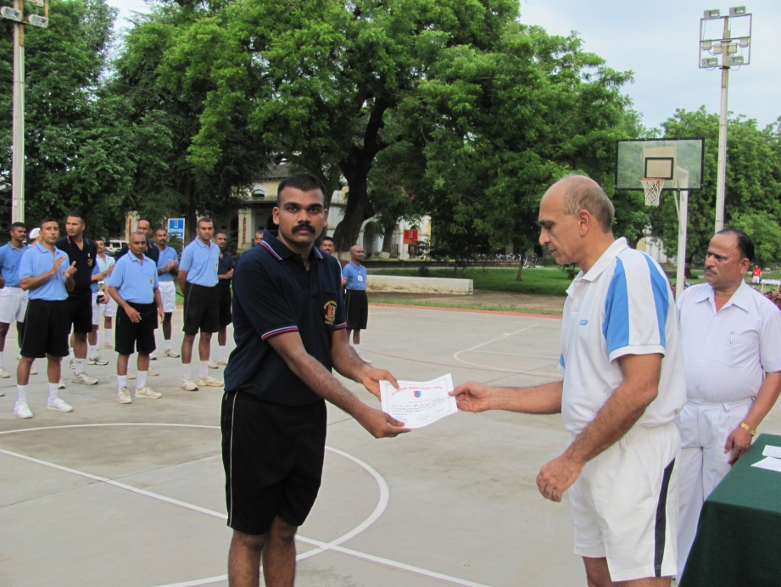
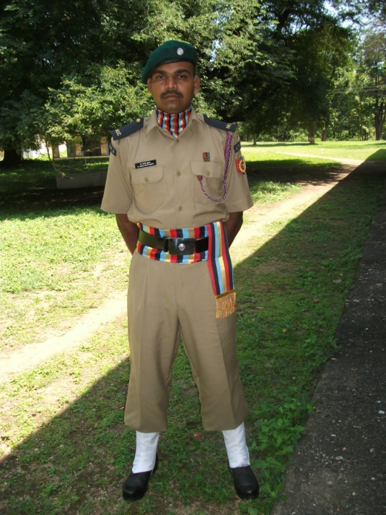
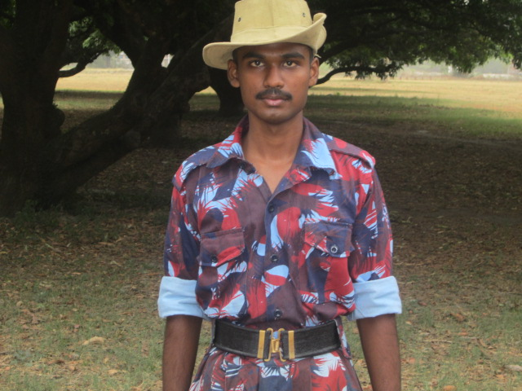
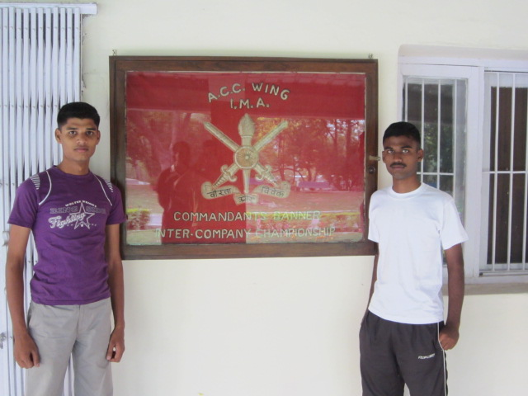
S.No | Name of the Event | Name of the participant | Dates | Place
2. | Army Attachment Camp (AAC) | Cdt. C. Prabhakaran  III- Mech | 14 -25th June 2012 | Indian Military Academy,Deharadun
S.No | Name of the Event | Name of the participant | Dates | Place
3 | National Integration Camp (NIC) | Cdt. R. Karthick prabhu, III-CSE  Cdt. S. Sibhyraj III-ECE | 16 -27 January 2013 | Junagarh, Gujarat
