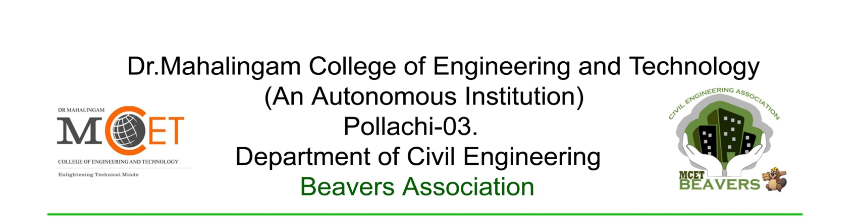
Date: 27.02.2015
REPORT
The Guest Lecture on “GATE Awareness Programme" by Mr.A.Saravanakumaran, Director, GATEFORUM, Coimbatore was held on 11.02.2015 at Mechanical seminar hall. The purpose of this session is to make the students gain the knowledge to crack GATE exam.
The students from second and third year of B.E Civil engineering participated in this interactive session. The session started by Selvan. Karthik Rajaram addressed the students for preparing gate exam. He highlighted the ways of preparation and the references for Fluid Mechanics & Water Resources. Then followed by Selvan.R.Manthiram@Karthik gave tips to the student for the preparation of Strength of materials. Selvi.N.Kasthuri shared her methods of studying & reference for Transportation Engineering & Surveying. Selvan.R.Rajasekar gave ideas for solving Mathematics & Aptitude, General ability. Selvan.M.Manoj Prabhagar discussed the references & preparation techniques for Geotechnical Engineering. Selvan.S.Parthasarathy dealt with subjects Environmental Engineering & gave tips to score more marks in it. Then, Mr.P.Gowdhamramkarthik, Assistant Professor/Civil discussed about the importance of GATE and tips to crack the exam. He shared his own experience and different ways for preparation. The session was continued by Mr.A.Saravanakumaran from Gate forum. He presented some videos regarding the student’s motivational speech, who cracked GATE exam with AIR rank. He discussed about the various possibilities for cracking gate exam and the credits of this exam. He also explained about the facilities and packages available in GATEFORUM for the students. Queries were discussed about the section.
At last, Mr.S.Syed Masoodhu staff in charge of beavers addressed the gathering and summarized the discussed points.
Prepared by
Rajkumar N Mr.S.Syed Masoodhu Dr.G.Jaisankar
Office Bearer/ Beavers Staff Incharge HOD/CIVIL

