S.No | Name of the Event | Name of the participant | Dates | Place
1 | Army Attachment Camp | Cdt. C.SARAVANAN , III Auto | 23 June- 04 July 2014 | Indian Military Academy, Dehradun.
NATIONAL CAMP ACHIVERS 2014-15

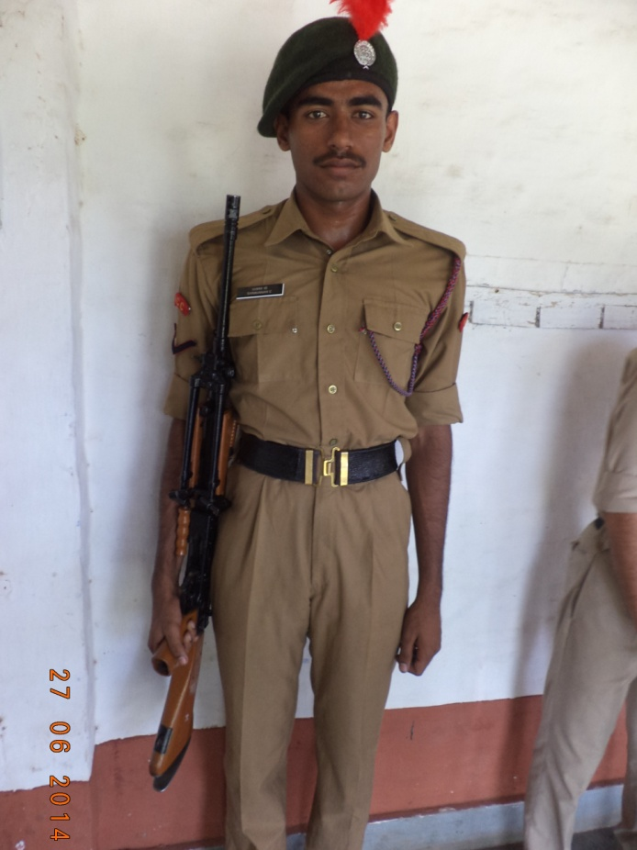
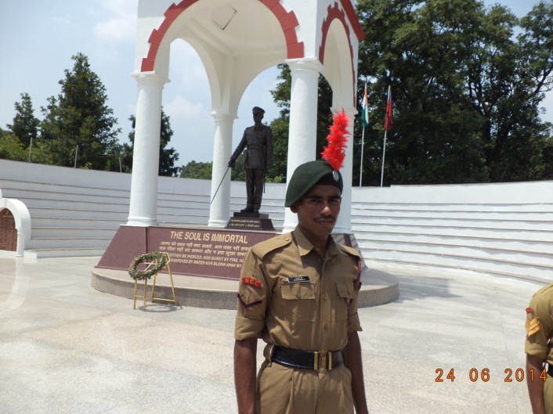
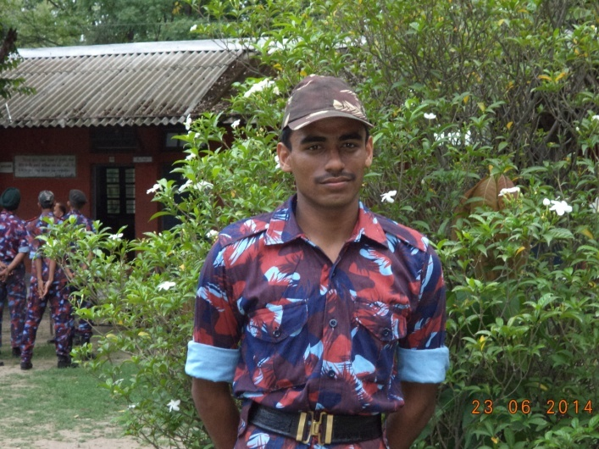
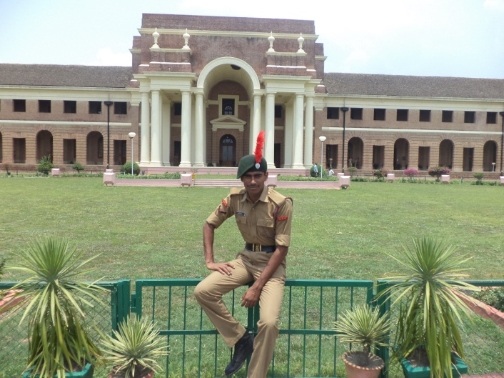

S.No | Name of the Event | Name of the participant | Dates | Place
2 | SSB Screening Course | M.S.P.VARRUN, III ICE | 15- 24 December 2014 | Officers Training Academy.Kamptee, Nagpur

S.No | Name of the Event | Name of the participant | Dates | Place
3 | SSB Screening Course | Cdt. V.ROOPA,  III BTech- IT | 17-26 Nov 2014 | Officers Training Academy, Gwalior

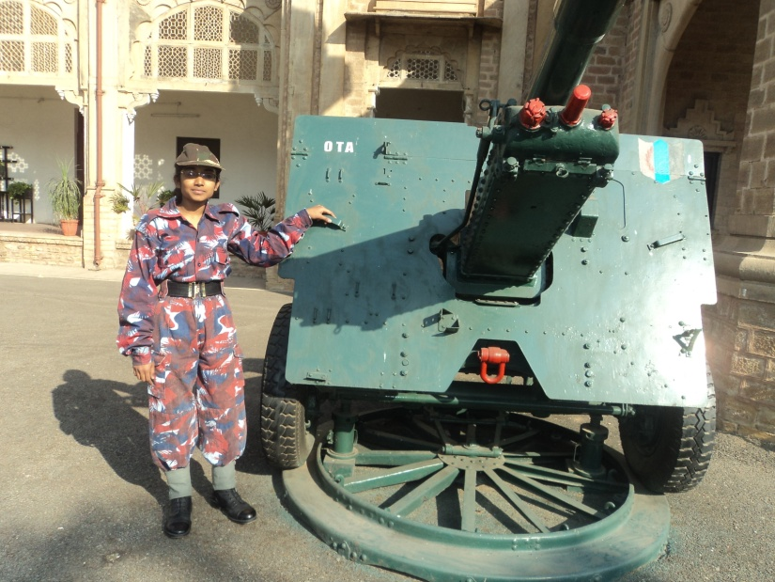
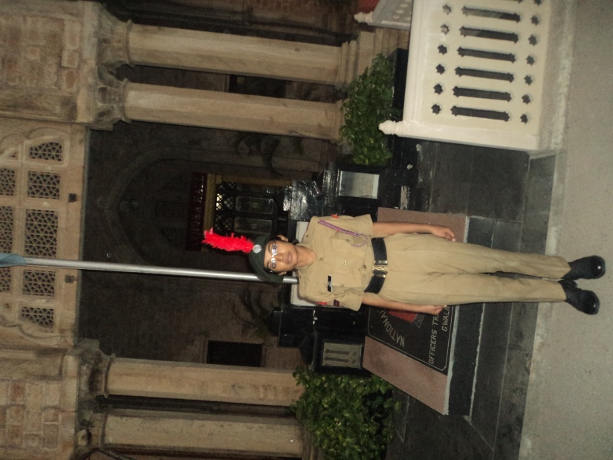

S.No | Name of the Event | Name of the participants | Dates | Place
4 | Army Attachment Camp | K.HARI PRASATH, III-BE MECH | 01-15 Sep 2014 | HQ 76 INF BDE SECUNDRABAD
 |  | P.MUTHU BHARATHI, III-BE CIVIL
 |  | K.PRAWIN, III EIE
 |  | S.SARAVANA SUNDARAM, III-BE MECH
 |  | P.SARAVANA PRIYAN, III-BE ECE
